**National University of Computer & Emerging Sciences, Karachi** 

**Computer Science Department**

**Fall 2024, Lab Manual - 04**

|  |  |
| --- | --- |
| **Course Code: CL-2005** | **Course: Database Systems Lab** |
| **Instructor(s):** | **Mubashir** |

**Contents:**

* Groups of Data (Group by, Having)
* Sub Queries (Single Row, Multiple and correlated)
* Sub Queries and DML
* Tasks

**Group by Statement:**

The GROUP BY statement group’s rows that have the same values in summary rows, like “Find the number of customers in each country”.

The GROUP BY statement is often used with aggregate functions (COUNT, MAX, MIN, SUM, AVG) to group the result-set by one or more columns.

**Group by Syntax**

|  |
| --- |
| **SELECT** column_name(s) **FROM** table_name **GROUP** **BY** column_name(s) |

|  |
| --- |
| **SELECT**      AVG(salary) as “average_salary”  **FROM**      employees  **GROUP** **BY** Department_id |

Sample Output:

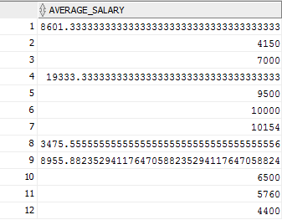

**Group by (Having)**

Having Clause is used with GROUP BY clause to restrict the groups of returned rows where condition is TRUE.

**Syntax:**

|  |
| --- |
| **SELECT** expression1, expression2, ... expression_n,   aggregate_function (aggregate_expression)  **FROM** [table](https://www.javatpoint.com/oracle-having-clause)_name  **WHERE** conditions  **GROUP** **BY** expression1, expression2, ... expression_n  **HAVING** having_condition; |

**HAVING Example: (with GROUP BY SUM function)**

|  |
| --- |
| **SELECT** item, SUM(sale) AS "Total sales"  **FROM** salesdepartment  **GROUP** **BY** item  **HAVING** SUM(sale) < 1000; |

**HAVING Example: (with GROUP BY MIN function)**

|  |
| --- |
| **SELECT** Department_ID,  MIN(salary) AS "Lowest salary"  **FROM** employees  **GROUP** **BY** Department_ID  **HAVING** MIN(salary) < 15000; |

**Sample Output:**

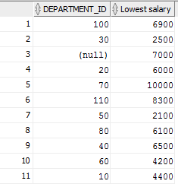

**HAVING Example: (with GROUP BY MAX function)**

|  |
| --- |
| **SELECT** Department_ID,  MAX(salary) AS "Highest salary"  **FROM** employees  **GROUP** **BY** Department_ID  **HAVING** MAX(salary) > 3000; |

**Sample Output:**

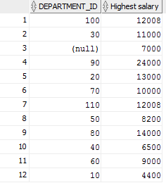

**Sub Queries:**

A Subquery is a query within another SQL query and embedded within the WHERE clause.

**Important Rule:**

* A subquery can be placed in a number of SQL clauses like WHERE clause, FROM clause, HAVING clause.
* You can use Subquery with SELECT, UPDATE, INSERT, DELETE statements along with the operators like =, <, >, >=, <=, IN, BETWEEN, etc.
* A subquery is a query within another query. The outer query is known as the main query, and the inner query is known as a subquery.
* Subqueries are on the right side of the comparison operator.
* A subquery is enclosed in parentheses.
* In the Subquery, ORDER BY command cannot be used. But GROUP BY command can be used to perform the same function as ORDER BY command.

**NOTE**:

Subqueries are useful when a query is based on unknown values.

**Sub Queries with SELECT Statement:**

Syntax:

|  |
| --- |
| **SELECT** column_name  **FROM** table_name  **WHERE** column_name expression operator  ( **SELECT** column_name  **FROM** table_name **WHERE** ... ); |

**Types of Subqueries**:

1. **Single Row Sub Query**: Sub query which returns single row output. They mark the usage of single row comparison operators, when used in WHERE conditions.
2. **Multiple row sub query**: Sub query returning multiple row output. They make use of multiple row comparison operators like IN, ANY, ALL. There can be sub queries returning multiple columns also.
3. **Correlated Sub Query**: Correlated subqueries depend on data provided by the outer query. This type of subquery also includes subqueries that use the EXISTS operator to test the existence of data rows satisfying specified criteria.

**Single Row Sub Queries:**

* Return only one row
* Use single-row comparison operators

|  |  |
| --- | --- |
| **Operator** | **Meaning** |
| = | Equal to |
| > | Greater than |
| >= | Greater than or equal to |
| < | Less than |
| <= | Less than or equal to |
| <> , =! | Not equal to |

|  |
| --- |
| **SELECT** First_Name, Job_ID **FROM** Employees **WHERE** job = ( **SELECT** job_ID **FROM** Employees **WHERE** empno=7369 ) |

Sample Output:

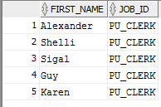

**Single Row Functions:**

**Finds the employees who have the highest salary:**

|  |
| --- |
| **SELECT**      employee_id, first_name, last_name, salary  **FROM**      employees  **WHERE**      salary = (**SELECT** MAX(salary) **FROM** employees) |

Sample Output:



**Finds all employees who salaries are greater than the average salary of all employees:**

|  |
| --- |
| **SELECT**      employee_id, first_name, last_name, salary  **FROM**      employees  **WHERE**      salary > (**SELECT** AVG(salary)  **FROM** employees) |

Sample Output:

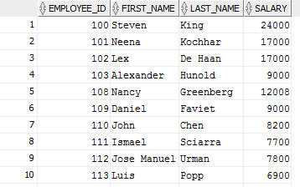

**Multiple row sub query:**

* Return more than one row
* Use multiple-row comparison operators
* [> ALL] More than the highest value returned by the subquery
* [< ALL] Less than the lowest value returned by the subquery
* [< ANY] Less than the highest value returned by the subquery
* [> ANY] More than the lowest value returned by the subquery
* [= A NY] Equal to any value returned by the subquery (same as IN)

**IN:**

|  |
| --- |
| **SELECT** first_name, department_id  **FROM** employees  **WHERE** department_id IN (**SELECT** Department_id  **FROM** departments  **WHERE** LOCATION_ID = 100) |

**Sample Output:**

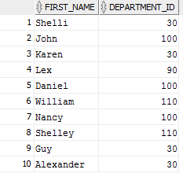

**ANY:**

|  |
| --- |
| **SELECT** employee_ID, First_Name, job_ID  **FROM** EMPLOYEES  **WHERE** SALARY < ANY  ( **SELECT** salary **FROM** EMPLOYEES **WHERE** JOB_ID = 'PU_CLERK' ); |

**Sample Output:**

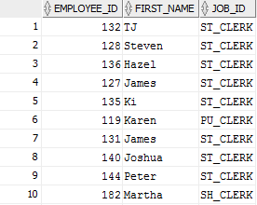

**ALL:**

|  |
| --- |
| **SELECT** employee_ID, First_Name, job_ID  **FROM** EMPLOYEES **WHERE** SALARY >All  ( **SELECT** salary **FROM** HR.EMPLOYEES **WHERE** JOB_ID = 'PU_CLERK' ) AND job_ID <> 'PU_CLERK' ; |

Sample Output:

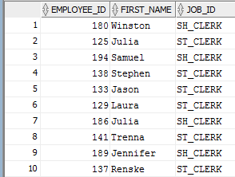

**Group By and HAVING IN SUB QUERIES:**

|  |
| --- |
| **SELECT** department_name, avg(salary)  **FROM** EMP_DETAILS_VIEW  **GROUP** BY department_name  **HAVING** avg(salary) > ( **SELECT** avg(salary) **FROM** EMPLOYEES); |

**Sample Output:**

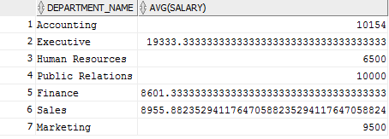

**SUBQUERIES AND DML:**

Subqueries with the INSERT Statement

* SQL subquery can also be used with the Insert statement. In the insert statement, data returned from the subquery is used to insert into another table.
* In the subquery, the selected data can be modified with any of the character, date functions.

**Syntax:**

|  |
| --- |
| **INSERT** INTO table_name (column1, column2, column3....)  **SELECT** *  **FROM** table_name  **WHERE** VALUE OPERATOR |

**You may login from a new user for DML sub Queries.**

**Example**: Let's assume we have an EMPLOYEE_BKP table available which is backup of EMPLOYEE table having all the attributes of Employees table

|  |
| --- |
| **INSERT** INTO EMPLOYEE_BKP  **SELECT** * FROM EMPLOYEES  **WHERE** job_ID IN (SELECT job_id  **FROM** jobs WHERE job_title='Accountant'); |

**Subqueries with the UPDATE Statement**

The subquery of SQL can be used in conjunction with the Update statement. When a subquery is used with the Update statement, then either single or multiple columns in a table can be updated.

**Syntax**

|  |
| --- |
| **UPDATE** table  **SET** column_name = new_value  **WHERE** VALUE OPERATOR     (**SELECT** COLUMN_NAME  **FROM** TABLE_NAME  **WHERE** condition); |

**Example:**

The given example updates the SALARY by 10 times in the EMPLOYEE table for all employee whose minimum salary is 3000.

|  |
| --- |
| **Update** employees  set salary= salary+(0.1*salary)  **WHERE** job_ID IN (SELECT job_ID  **FROM** jobs **WHERE** min_salary=3000); |

**Subqueries with the DELETE Statement**

The subquery of SQL can be used in conjunction with the Delete statement just like any other statement mentioned above.

**Syntax**

|  |
| --- |
| **DELETE** FROM TABLE_NAME  **WHERE** VALUE OPERATOR     (**SELECT** COLUMN_NAME  **FROM** TABLE_NAME  **WHERE** condition); |

**Example:**

Let's assume we have an EMPLOYEE_BKP table available which is a backup of EMPLOYEE table. The given example deletes the records from the EMPLOYEE_BKP table for all EMPLOYEE whose end date is ’31-DEC-06’.

|  |
| --- |
| **Delete** from employee_BKP  **WHERE** job_ID IN (**SELECT** job_ID  **FROM** job_History **WHERE** end_Date='31-Dec-06'); |

|  |
| --- |
| **SELECT**  e.employee_id,  e.first_name,  e.last_name,  (**SELECT** job_title **FROM** jobs **WHERE** job_id = e.job_id) AS job_title,  (**SELECT** department_name **FROM** departments **WHERE** department_id = e.department_id) **AS** department_name,  (**SELECT** city **FROM** locations **WHERE** location_id = d.location_id) AS department_location,  (**SELECT** region_name **FROM** regions **WHERE** region_id = r.region_id) AS region_name  **FROM**  employees e,  departments d,  locations l,  regions r  **WHERE**  e.department_id = d.department_id  AND d.location_id = l.location_id; |

**(ROWNUM) LIMIT Function:**

In SQL databases, limit function is used to restrict the number of rows returned by a query. Here’s a simple explanation of how LIMIT function works:

**Example:**

**Display only the top 5 highest salaries from an employee’s table**

|  |
| --- |
| **SELECT** salary **FROM** (  **SELECT** salary **FROM** employees  **ORDER** **BY** salary **DESC**  )  **WHERE** ROWNUM <= 5; |

**Lab Tasks:**

1. Write a query to determine who earns more than Mr. Ozer.
2. Write a query in SQL to display the department code and name for all departments which located in the city London.
3. Write a query in SQL to display the first and last name, salary, and department ID for all those employees who work in that department having the department name ‘Shipping’ but not the job_id ‘IT_PROG’.
4. Write a query in SQL to display the full name, email, and hire date for all those employees who was hired after the employee whose ID is 165.
5. Create table Job_History1 like the job_history table of HR user. Insert records into Job_History1 for jobs with an end date of '19-DEC-07' from hr.Job_History.
6. Insert 5 rows in the Job_History1 table and delete records from Job_History1 where the job_id is ' AC_ACCOUNT'.
7. Delete records from Job_History1 for departments with the name 'IT'.
8. Write a query to identify all the employees who earn more than the average of all employees and who work in any of the IT departments.
9. Retrieve the 03 highest salaries from the employees table using a subquery.
10. Write a query to display the employee name (first name and last name) and hire date for all employees in the same department as Clara.
11. Write a query in SQL to display the city of the employee whose ID 134.
12. Write a query in SQL to display the first and last name, salary, and department ID for those employees who earn less than the average salary of all the employees, and also work at the department where the employee Laura is working.
13. Write a query to find out which employees have a manager who works for a department based in the US.